Ex.no:7b | DATA VISUALIZATION USING TABLEAU- HOTEL BOOKING DATASET

Aim
To connect, analyze, visualize, and create interactive dashboards using Tableau with the Hotel Booking Demand Dataset to effectively analyze hotel booking patterns, customer behavior, booking cancellations, and demand trends across different hotels, countries, customer types, market segments, and time periods..

Software Requirements
• Tableau Desktop / Tableau Public
• Microsoft Excel
• CSV Dataset
• Windows Operating System

Theory
Tableau is a powerful Business Intelligence (BI) and Data Visualization tool used to create interactive dashboards and reports.
The Hotel Booking Demand Dataset contains information about hotel bookings, customer behavior, and cancellations, including:
• Hotel type
• Booking status and cancellation
• Lead time and arrival dates
• Number of guests and length of stay
• Meal and customer type
• Country and market segment
• Room type and deposit type
• Average daily rate and special requests
Tableau allows users to analyze this data and identify patterns, trends, customer behavior, and cancellation factors across different hotels and time periods.

Tableau Architecture
Hotel Booking Demand Dataset
↓
Data Connection
↓
Worksheets
↓
Visualizations
↓
Dashboard
↓
Story

Learning Outcomes
After completing this experiment, students
will be able to:
✓ Connect the Hotel Booking Demand Dataset to Tableau
✓ Create worksheets using different dimensions and measures
✓ Generate charts and visualizations
✓ Analyze hotel booking trends over time
✓ Apply filters and parameters
✓ Create calculated fields
✓ Build interactive dashboards
✓ Create stories for data analysis

Sample Dataset

Hotel Booking Demand Dataset
hotel | is_canceled | lead_time | arrival_date_year | arrival_date_month | arrival_date_week_number
Resort Hotel | 0 | 342 | 2015 | July | 27
Resort Hotel | 0 | 737 | 2015 | July | 27
Resort Hotel | 0 | 7 | 2015 | July | 27
Resort Hotel | 0 | 13 | 2015 | July | 27
Resort Hotel | 0 | 14 | 2015 | July | 27
Resort Hotel | 0 | 14 | 2015 | July | 27
The actual GTD contains a much larger number of records and columns.

Algorithm 1 – Connecting Data Source

Step 1
Open Tableau Desktop.

Step 2
Select Connect.

Step 3
Choose Microsoft Excel or Text File depending on the dataset format.

Step 4
Browse and select the Global Terrorism Dataset.

Step 5
Open the dataset.

Step 6
Verify the imported fields such as:
- Year
- Country
- Region
- Attack Type
- Fatalities
- Wounded
- Terrorist Group

Procedure
Tableau
↓
Connect
↓
Excel / Text File
↓
Hotel Booking Demand Dataset
↓
Open
↓
Verify Data

Output
Hotel Booking Demand Dataset loaded into Tableau successfully.

Algorithm 2 – Creating Worksheet

Step 1
Open Sheet 1.

Step 2
Drag Country to Columns.

Step 3
Drag Number of Records to Rows.

Step 4
Select an appropriate visualization.

Step 5
Analyze the number of hotel booking by country.

Output
Worksheet created successfully.

Interpretation
The worksheet displays the number of hotel booking recorded for different countries.
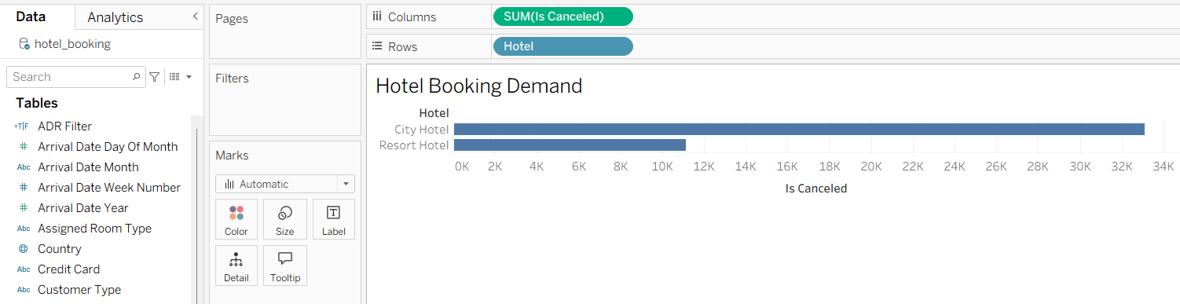

Algorithm 3 – Bar Chart Creation

Objective
To compare the number of hotel booking across different countries.

Step 1
Drag Country → Columns.

Step 2
Drag Number of Records → Rows.

Step 3
Select Bar Chart from Show Me.

Step 4
Enable Show Mark Labels.

Step 5
Sort the countries in descending order.

Output Visualization

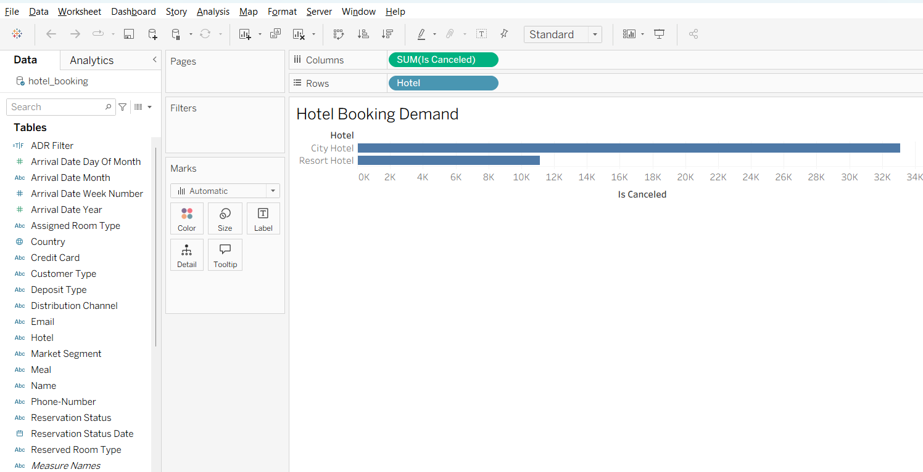
Interpretation
The bar chart helps identify hotel booking demand on different hotels.

Algorithm 4 – Pie Chart Creation

Objective
To analyze the distribution of hotel booking based on hotel name.

Step 1
Drag Hotel Name to the view.

Step 2
Select Pie Chart from Show Me.

Step 3
Drag Number of Records to Angle.

Step 4
Drag Hotel Name to Color.

Step 5
Enable Show Labels.

Output Visualization

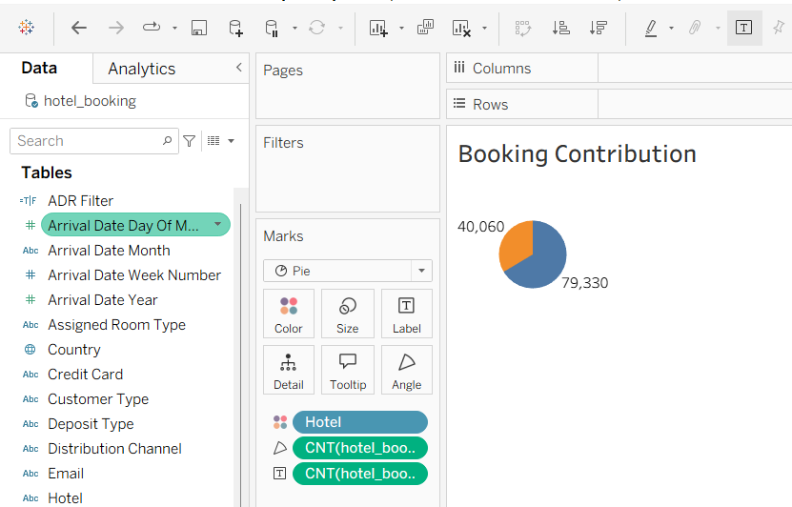

Interpretation
The pie chart shows the proportion of different hotel and the number of customers visiting the hotel.

Algorithm 5 – Line Chart Creation

Objective
To analyze the trend of hotel booking over the months of a year.

Step 1
Drag Months → Columns.

Step 2
Drag Number of Records → Rows.

Step 3
Select Line Chart.

Step 4
Apply appropriate formatting.

Step 5
Analyze the trend.

Output Visualization

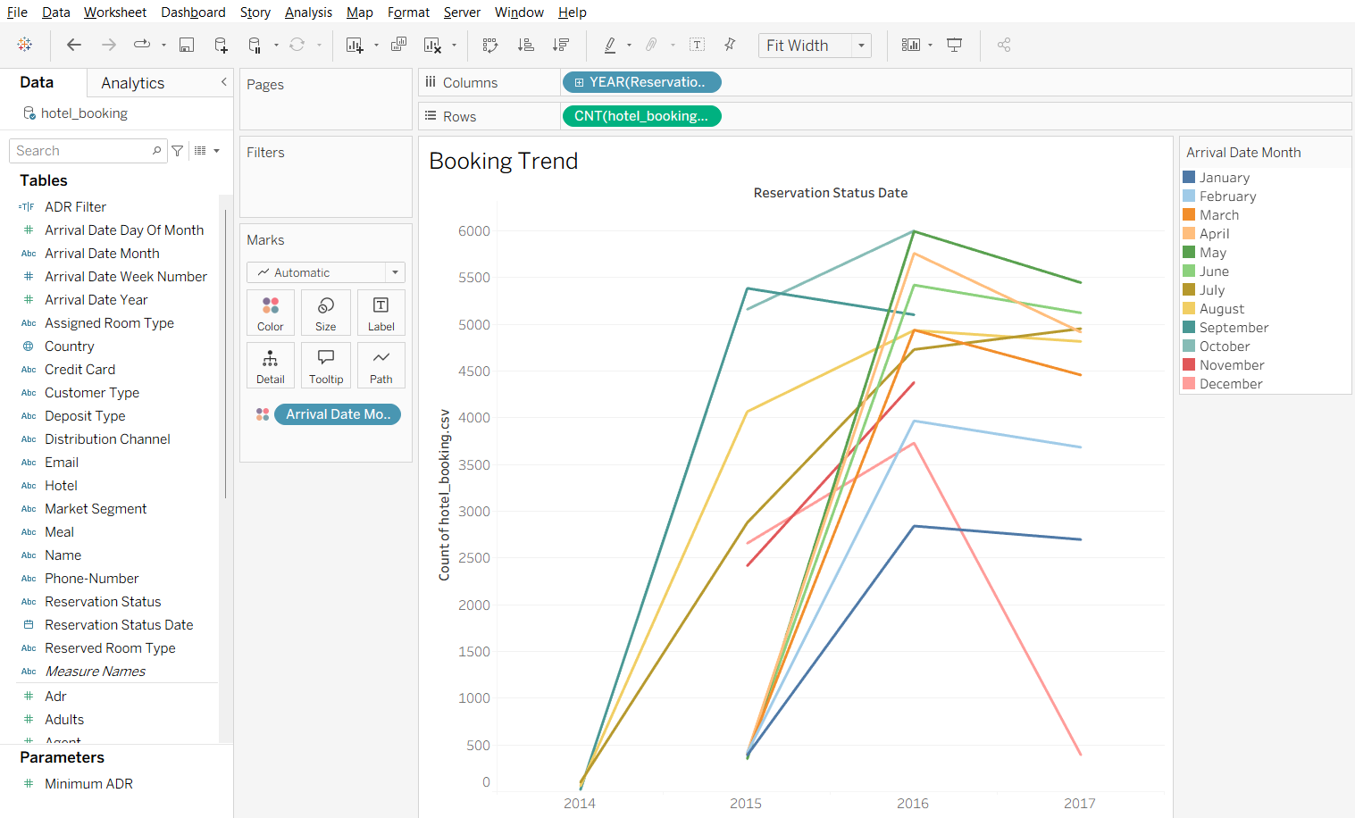

Interpretation
The line chart shows how the number of recorded hotel booking changes over time.
It helps identify:
• Increasing trends
• Decreasing trends
• Peak periods
• Changes in hotel booking activity

Algorithm 6 – Creating Calculated Field
Objective
To calculate the Total Stay Nights for hotel bookings.
Step 1
Select:
Analysis → Create Calculated Field
Step 2
Enter the field name:
Total Stay Nights
Step 3
Enter the formula:
[stays_in_weekend_nights]
+
[stays_in_week_nights]
Step 4
Click OK.
Output
Hotel | Weekend Nights | Week Nights | Total Stay Nights
City Hotel | 2 | 3 | 5
Resort Hotel | 3 | 4 | 7
City Hotel | 1 | 2 | 3
Resort Hotel | 2 | 5 | 7
Interpretation
The calculated field combines weekend and weekday nights to determine the total duration of a guest's stay.

Algorithm 7 – Applying Filters
Objective
To analyze hotel bookings for a specific hotel type.
Step 1
Drag Hotel to the Filters shelf.
Step 2
Select the required hotel type.
Step 3
Apply the filter.
Step 4
Observe the updated charts.
Example
Filter: Hotel = City Hotel
Output
The visualization displays only bookings recorded for City Hotel.
Interpretation
Filters allow users to focus on a specific hotel type and perform detailed analysis.

Algorithm 8 – Creating Parameter
Objective
To display hotel bookings based on a user-defined minimum Average Daily Rate.
Step 1
Select:
Create Parameter
Step 2
Specify the parameter name:
Minimum ADR
Step 3
Set the data type as:
Float
Step 4
Set the required minimum value.
Step 5
Create a calculated field using the parameter.
Formula
[adr] >= [Minimum ADR]
Example
Minimum ADR = 100
Output
The visualization displays hotel bookings where the Average Daily Rate is 100 or more.
Interpretation
Parameters allow users to dynamically control the analysis based on selected ADR values.

Algorithm 9 – Dashboard Creation
Objective
To create an interactive Hotel Booking Analysis Dashboard.
Step 1
Create multiple worksheets.
Step 2
Select Dashboard → New Dashboard.
Step 3
Drag the required worksheets into the dashboard.
Step 4
Arrange the charts.
Step 5
Add filters for:
- Year
- Hotel
- Customer Type
- Market Segment
Step 6
Add appropriate titles.
Dashboard Analysis
Total Hotel Bookings
Number of records in the dataset
Total Cancellations
Number of cancelled bookings
Average ADR
Average Daily Rate of bookings
Total Stay Nights
Sum of total stay nights
Interpretation
The dashboard provides a consolidated view of hotel booking demand, customer behavior, pricing, and cancellations and allows users to interactively analyze the data using filters.

Algorithm 10 – Story Creation
Objective
To present the analysis of hotel booking demand, customer behavior, and cancellations through a sequence of visual insights.
Step 1
Create the required worksheets.
Step 2
Create the dashboard.
Step 3
Select Story → New Story.
Step 4
Add the dashboard and required worksheets as story points.
Step 5
Arrange the story points in a logical sequence.
Step 6
Present the findings.
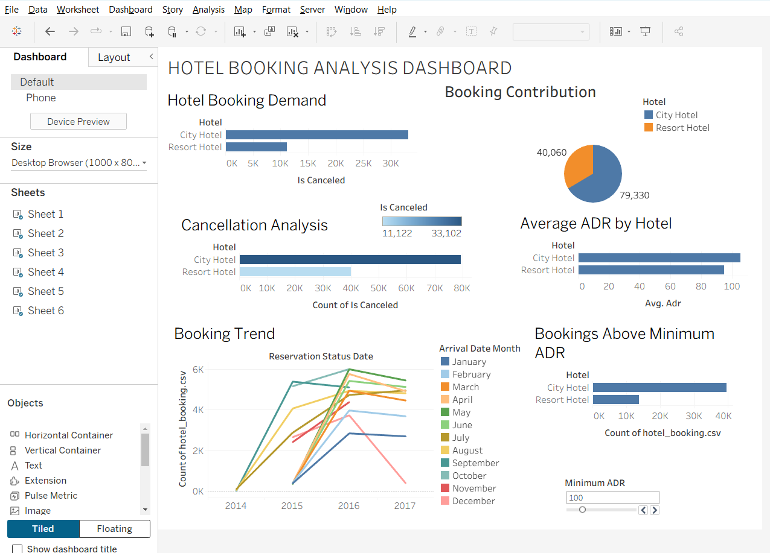

Example Story
Story Point 1
Overall Hotel Booking Analysis
Displays the overall number of hotel bookings, cancellations, average ADR, and total stay nights.
Story Point 2
Year-wise Booking Trend
Shows how hotel bookings have changed over the years.
Story Point 3
Hotel-wise Analysis
Compares booking demand and average ADR between City Hotel and Resort Hotel.
Story Point 4
Customer Behavior Analysis
Shows customer types, repeated guests, market segments, and booking behavior.
Story Point 5
Cancellation Analysis
Analyzes booking cancellations based on hotel type, customer type, market segment, and lead time.
Story Point 6
Final Conclusions
Summarizes the major patterns and observations obtained from the hotel booking dataset.

Applications
Hotel Management
Analysis of booking demand, customer behavior, and cancellations
Revenue Management
Analysis of ADR, stay duration, and pricing patterns
Customer Analytics
Understanding customer types, repeated guests, and booking preferences
Business Intelligence
Interactive visualization and dashboard-based analysis
Decision Making
Identification of booking and cancellation patterns for better planning
Data Analytics
Interactive visualization and exploratory data analysis

Result

